[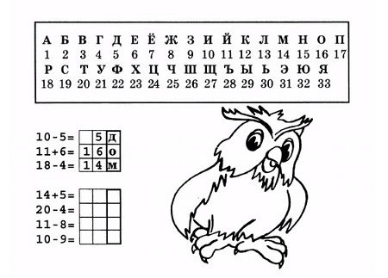](https://ok.ru/dk?cmd=PopLayerPhoto&st.layer.cmd=PopLayerPhotoOuter&st.layer.type=GROUP&st.layer.revNav=off&st.layer.limitedUi=false&st.layer.closeLayers=off&st.layer.sphotoIds=894719795502;894719795246;894719794990;894719794734;894719794478;894719794222;894719793966;894719793710;894719793454;894719793198&st.layer.showNav=on&st.layer.photoAlbumId=57769909354542&st.layer.epm=off&st.layer.photoId=894719795502&st.layer.wasRedirect,=off&st.layer.opl=off&st.layer.navStartPhotoId=894719795502&st.layer.navStartAlbumId,=57769909354542&st.layer.sbd=off&st.cmd=altGroupMain&st.groupId=57769908502574&st.referenceName=mentalnarif&st._aid=GroupTopicLayer_openPhotoLayer)

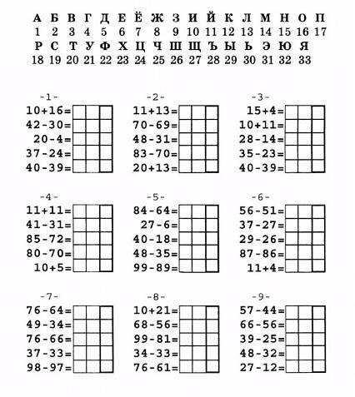

[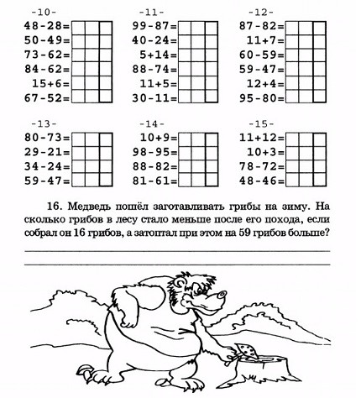](https://ok.ru/dk?cmd=PopLayerPhoto&st.layer.cmd=PopLayerPhotoOuter&st.layer.type=GROUP&st.layer.revNav=off&st.layer.limitedUi=false&st.layer.closeLayers=off&st.layer.sphotoIds=894719795502;894719795246;894719794990;894719794734;894719794478;894719794222;894719793966;894719793710;894719793454;894719793198&st.layer.showNav=on&st.layer.photoAlbumId=57769909354542&st.layer.epm=off&st.layer.photoId=894719794990&st.layer.wasRedirect,=off&st.layer.opl=off&st.layer.navStartPhotoId=894719794990&st.layer.navStartAlbumId,=57769909354542&st.layer.sbd=off&st.cmd=altGroupMain&st.groupId=57769908502574&st.referenceName=mentalnarif&st._aid=GroupTopicLayer_openPhotoLayer)

[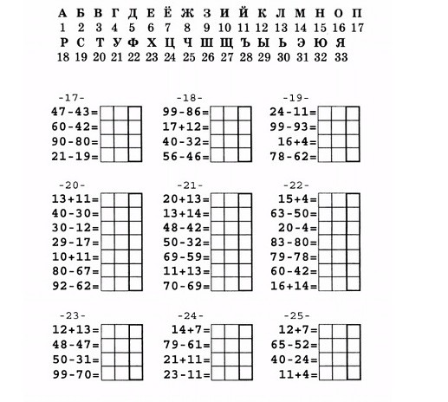](https://ok.ru/dk?cmd=PopLayerPhoto&st.layer.cmd=PopLayerPhotoOuter&st.layer.type=GROUP&st.layer.revNav=off&st.layer.limitedUi=false&st.layer.closeLayers=off&st.layer.sphotoIds=894719795502;894719795246;894719794990;894719794734;894719794478;894719794222;894719793966;894719793710;894719793454;894719793198&st.layer.showNav=on&st.layer.photoAlbumId=57769909354542&st.layer.epm=off&st.layer.photoId=894719794734&st.layer.wasRedirect,=off&st.layer.opl=off&st.layer.navStartPhotoId=894719794734&st.layer.navStartAlbumId,=57769909354542&st.layer.sbd=off&st.cmd=altGroupMain&st.groupId=57769908502574&st.referenceName=mentalnarif&st._aid=GroupTopicLayer_openPhotoLayer)

[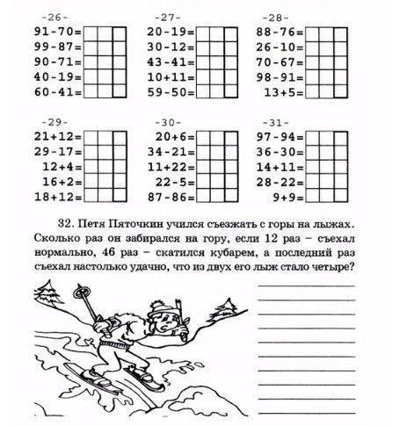](https://ok.ru/dk?cmd=PopLayerPhoto&st.layer.cmd=PopLayerPhotoOuter&st.layer.type=GROUP&st.layer.revNav=off&st.layer.limitedUi=false&st.layer.closeLayers=off&st.layer.sphotoIds=894719795502;894719795246;894719794990;894719794734;894719794478;894719794222;894719793966;894719793710;894719793454;894719793198&st.layer.showNav=on&st.layer.photoAlbumId=57769909354542&st.layer.epm=off&st.layer.photoId=894719794478&st.layer.wasRedirect,=off&st.layer.opl=off&st.layer.navStartPhotoId=894719794478&st.layer.navStartAlbumId,=57769909354542&st.layer.sbd=off&st.cmd=altGroupMain&st.groupId=57769908502574&st.referenceName=mentalnarif&st._aid=GroupTopicLayer_openPhotoLayer)

[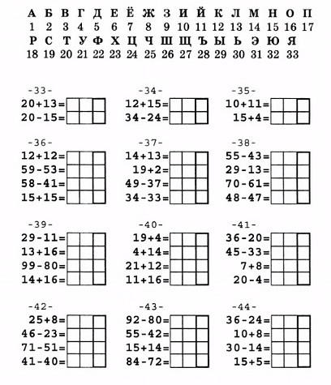](https://ok.ru/dk?cmd=PopLayerPhoto&st.layer.cmd=PopLayerPhotoOuter&st.layer.type=GROUP&st.layer.revNav=off&st.layer.limitedUi=false&st.layer.closeLayers=off&st.layer.sphotoIds=894719795502;894719795246;894719794990;894719794734;894719794478;894719794222;894719793966;894719793710;894719793454;894719793198&st.layer.showNav=on&st.layer.photoAlbumId=57769909354542&st.layer.epm=off&st.layer.photoId=894719794222&st.layer.wasRedirect,=off&st.layer.opl=off&st.layer.navStartPhotoId=894719794222&st.layer.navStartAlbumId,=57769909354542&st.layer.sbd=off&st.cmd=altGroupMain&st.groupId=57769908502574&st.referenceName=mentalnarif&st._aid=GroupTopicLayer_openPhotoLayer)

[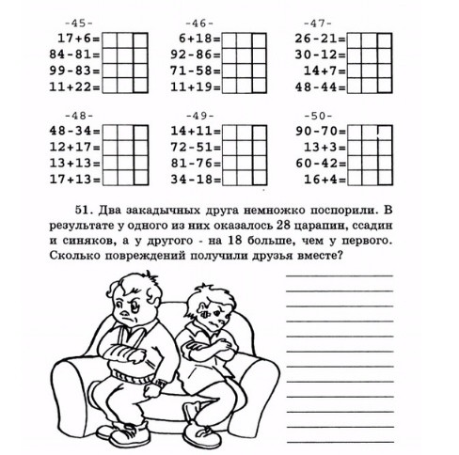](https://ok.ru/dk?cmd=PopLayerPhoto&st.layer.cmd=PopLayerPhotoOuter&st.layer.type=GROUP&st.layer.revNav=off&st.layer.limitedUi=false&st.layer.closeLayers=off&st.layer.sphotoIds=894719795502;894719795246;894719794990;894719794734;894719794478;894719794222;894719793966;894719793710;894719793454;894719793198&st.layer.showNav=on&st.layer.photoAlbumId=57769909354542&st.layer.epm=off&st.layer.photoId=894719793966&st.layer.wasRedirect,=off&st.layer.opl=off&st.layer.navStartPhotoId=894719793966&st.layer.navStartAlbumId,=57769909354542&st.layer.sbd=off&st.cmd=altGroupMain&st.groupId=57769908502574&st.referenceName=mentalnarif&st._aid=GroupTopicLayer_openPhotoLayer)

[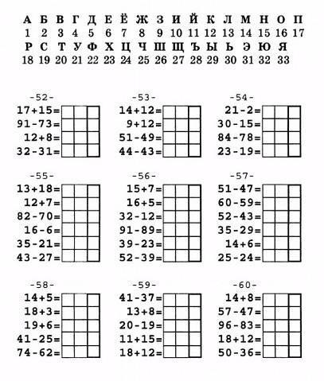](https://ok.ru/dk?cmd=PopLayerPhoto&st.layer.cmd=PopLayerPhotoOuter&st.layer.type=GROUP&st.layer.revNav=off&st.layer.limitedUi=false&st.layer.closeLayers=off&st.layer.sphotoIds=894719795502;894719795246;894719794990;894719794734;894719794478;894719794222;894719793966;894719793710;894719793454;894719793198&st.layer.showNav=on&st.layer.photoAlbumId=57769909354542&st.layer.epm=off&st.layer.photoId=894719793710&st.layer.wasRedirect,=off&st.layer.opl=off&st.layer.navStartPhotoId=894719793710&st.layer.navStartAlbumId,=57769909354542&st.layer.sbd=off&st.cmd=altGroupMain&st.groupId=57769908502574&st.referenceName=mentalnarif&st._aid=GroupTopicLayer_openPhotoLayer)

[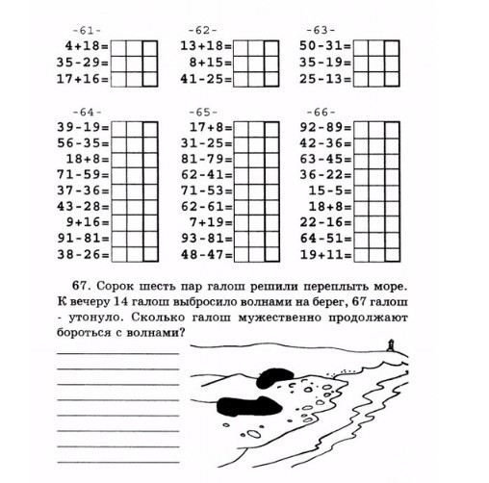](https://ok.ru/dk?cmd=PopLayerPhoto&st.layer.cmd=PopLayerPhotoOuter&st.layer.type=GROUP&st.layer.revNav=off&st.layer.limitedUi=false&st.layer.closeLayers=off&st.layer.sphotoIds=894719795502;894719795246;894719794990;894719794734;894719794478;894719794222;894719793966;894719793710;894719793454;894719793198&st.layer.showNav=on&st.layer.photoAlbumId=57769909354542&st.layer.epm=off&st.layer.photoId=894719793454&st.layer.wasRedirect,=off&st.layer.opl=off&st.layer.navStartPhotoId=894719793454&st.layer.navStartAlbumId,=57769909354542&st.layer.sbd=off&st.cmd=altGroupMain&st.groupId=57769908502574&st.referenceName=mentalnarif&st._aid=GroupTopicLayer_openPhotoLayer)

[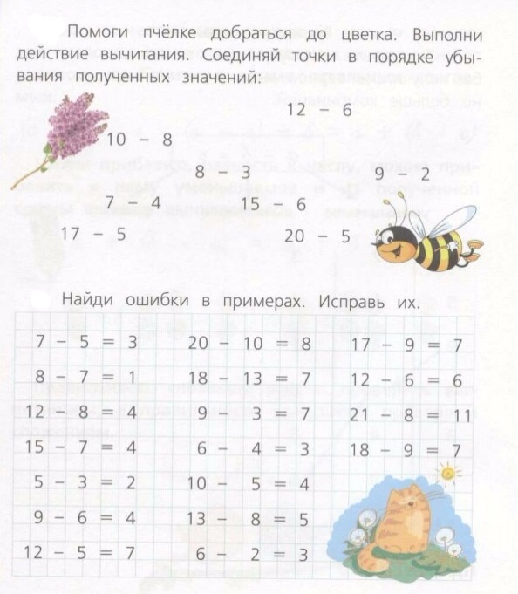](https://ok.ru/dk?cmd=PopLayerPhoto&st.layer.cmd=PopLayerPhotoOuter&st.layer.type=GROUP&st.layer.revNav=off&st.layer.limitedUi=false&st.layer.closeLayers=off&st.layer.sphotoIds=896259943726;896259943470;896259943214;896259942958;896259942702;896259942446;896259942190&st.layer.showNav=on&st.layer.photoAlbumId=57769909354542&st.layer.epm=off&st.layer.photoId=896259942190&st.layer.wasRedirect,=off&st.layer.opl=off&st.layer.navStartPhotoId=896259942190&st.layer.navStartAlbumId,=57769909354542&st.layer.sbd=off&st.cmd=altGroupMain&st.groupId=57769908502574&st.referenceName=mentalnarif&st._aid=GroupTopicLayer_openPhotoLayer)[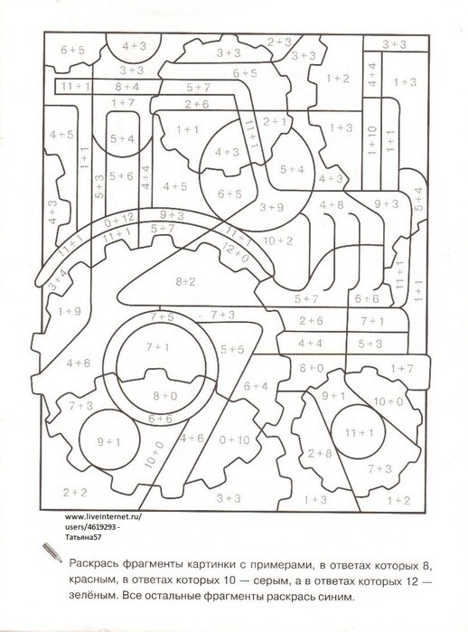](https://ok.ru/dk?cmd=PopLayerPhoto&st.layer.cmd=PopLayerPhotoOuter&st.layer.type=GROUP&st.layer.revNav=off&st.layer.limitedUi=false&st.layer.closeLayers=off&st.layer.sphotoIds=897039102766;897039102510;897039102254;897039101998;897039101742;897039101486;897039101230;897039100974;897039100718;897039100462&st.layer.showNav=on&st.layer.photoAlbumId=57769909354542&st.layer.epm=off&st.layer.photoId=897039101998&st.layer.wasRedirect,=off&st.layer.opl=off&st.layer.navStartPhotoId=897039101998&st.layer.navStartAlbumId,=57769909354542&st.layer.sbd=off&st.cmd=altGroupMain&st.groupId=57769908502574&st.referenceName=mentalnarif&st._aid=GroupTopicLayer_openPhotoLayer)[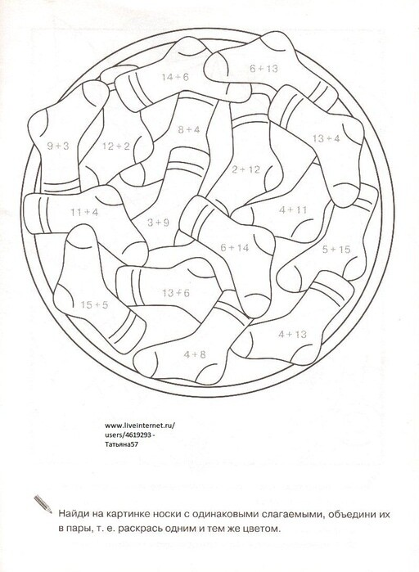](https://ok.ru/dk?cmd=PopLayerPhoto&st.layer.cmd=PopLayerPhotoOuter&st.layer.type=GROUP&st.layer.revNav=off&st.layer.limitedUi=false&st.layer.closeLayers=off&st.layer.sphotoIds=897039102766;897039102510;897039102254;897039101998;897039101742;897039101486;897039101230;897039100974;897039100718;897039100462&st.layer.showNav=on&st.layer.photoAlbumId=57769909354542&st.layer.epm=off&st.layer.photoId=897039100974&st.layer.wasRedirect,=off&st.layer.opl=off&st.layer.navStartPhotoId=897039100974&st.layer.navStartAlbumId,=57769909354542&st.layer.sbd=off&st.cmd=altGroupMain&st.groupId=57769908502574&st.referenceName=mentalnarif&st._aid=GroupTopicLayer_openPhotoLayer)[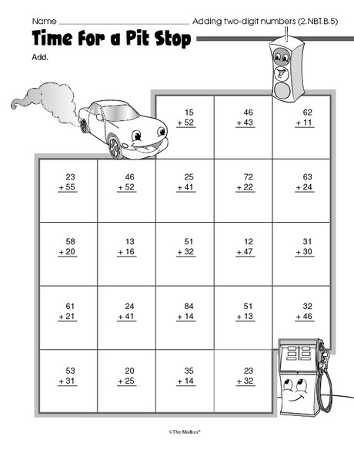](https://ok.ru/dk?cmd=PopLayerPhoto&st.layer.cmd=PopLayerPhotoOuter&st.layer.type=GROUP&st.layer.revNav=off&st.layer.limitedUi=false&st.layer.closeLayers=off&st.layer.sphotoIds=896466889262;896466889006;896466888750;896466888494;896466888238;896466887982;896466887726&st.layer.showNav=on&st.layer.photoAlbumId=57769909354542&st.layer.epm=off&st.layer.photoId=896466887982&st.layer.wasRedirect,=off&st.layer.opl=off&st.layer.navStartPhotoId=896466887982&st.layer.navStartAlbumId,=57769909354542&st.layer.sbd=off&st.cmd=altGroupMain&st.groupId=57769908502574&st.referenceName=mentalnarif&st._aid=GroupTopicLayer_openPhotoLayer)[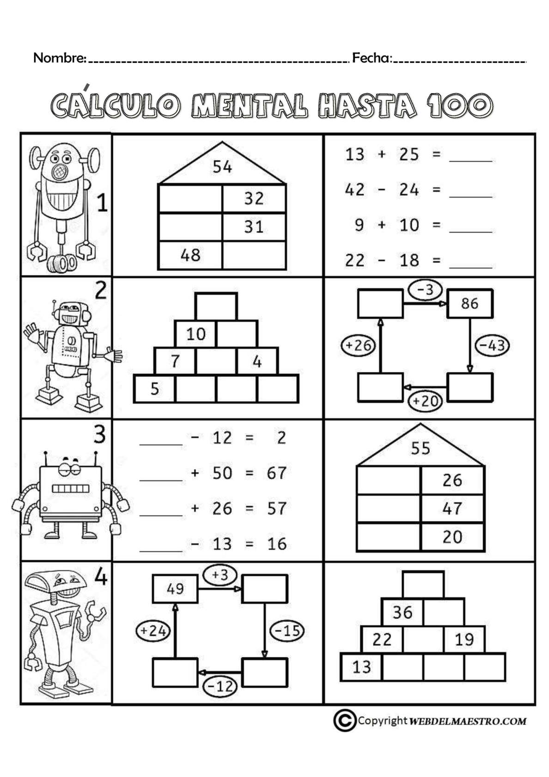](https://ok.ru/dk?cmd=PopLayerPhoto&st.layer.cmd=PopLayerPhotoOuter&st.layer.type=GROUP&st.layer.revNav=off&st.layer.limitedUi=false&st.layer.closeLayers=off&st.layer.sphotoIds=896342149934;896342149678;896342149422;896342149166;896342148910;896342148654;896342148398;896342148142;896342147886&st.layer.showNav=on&st.layer.photoAlbumId=57769909354542&st.layer.epm=off&st.layer.photoId=896342149422&st.layer.wasRedirect,=off&st.layer.opl=off&st.layer.navStartPhotoId=896342149422&st.layer.navStartAlbumId,=57769909354542&st.layer.sbd=off&st.cmd=altGroupMain&st.groupId=57769908502574&st.referenceName=mentalnarif&st._aid=GroupTopicLayer_openPhotoLayer)[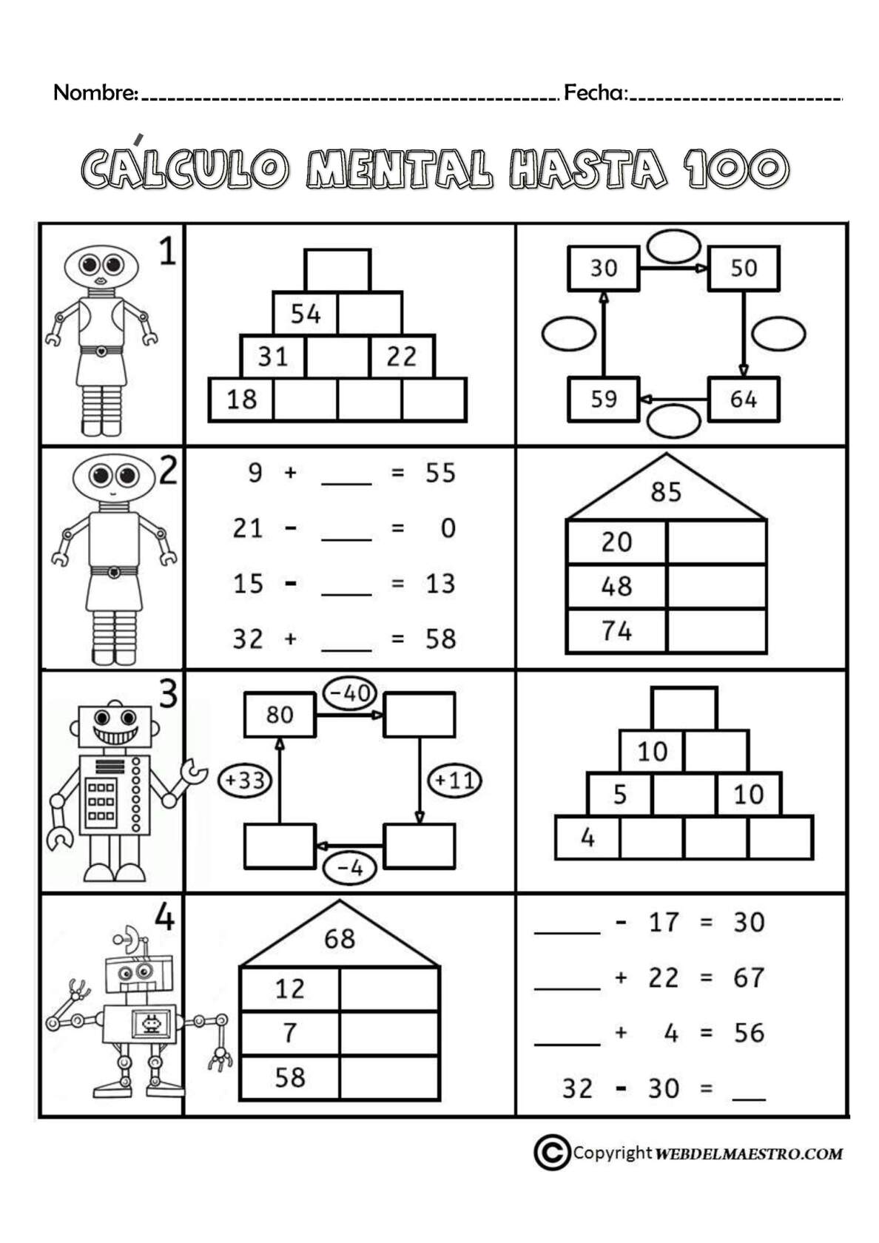](https://ok.ru/dk?cmd=PopLayerPhoto&st.layer.cmd=PopLayerPhotoOuter&st.layer.type=GROUP&st.layer.revNav=off&st.layer.limitedUi=false&st.layer.closeLayers=off&st.layer.sphotoIds=896342149934;896342149678;896342149422;896342149166;896342148910;896342148654;896342148398;896342148142;896342147886&st.layer.showNav=on&st.layer.photoAlbumId=57769909354542&st.layer.epm=off&st.layer.photoId=896342148910&st.layer.wasRedirect,=off&st.layer.opl=off&st.layer.navStartPhotoId=896342148910&st.layer.navStartAlbumId,=57769909354542&st.layer.sbd=off&st.cmd=altGroupMain&st.groupId=57769908502574&st.referenceName=mentalnarif&st._aid=GroupTopicLayer_openPhotoLayer)[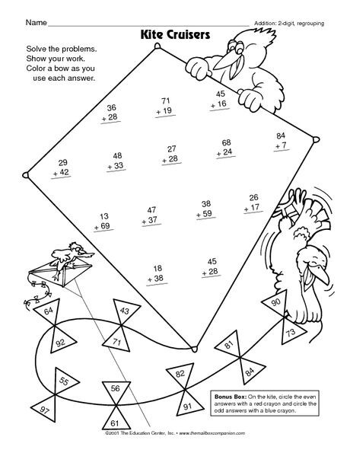](https://ok.ru/dk?cmd=PopLayerPhoto&st.layer.cmd=PopLayerPhotoOuter&st.layer.type=GROUP&st.layer.revNav=off&st.layer.limitedUi=false&st.layer.closeLayers=off&st.layer.sphotoIds=896466889262;896466889006;896466888750;896466888494;896466888238;896466887982;896466887726&st.layer.showNav=on&st.layer.photoAlbumId=57769909354542&st.layer.epm=off&st.layer.photoId=896466888494&st.layer.wasRedirect,=off&st.layer.opl=off&st.layer.navStartPhotoId=896466888494&st.layer.navStartAlbumId,=57769909354542&st.layer.sbd=off&st.cmd=altGroupMain&st.groupId=57769908502574&st.referenceName=mentalnarif&st._aid=GroupTopicLayer_openPhotoLayer)[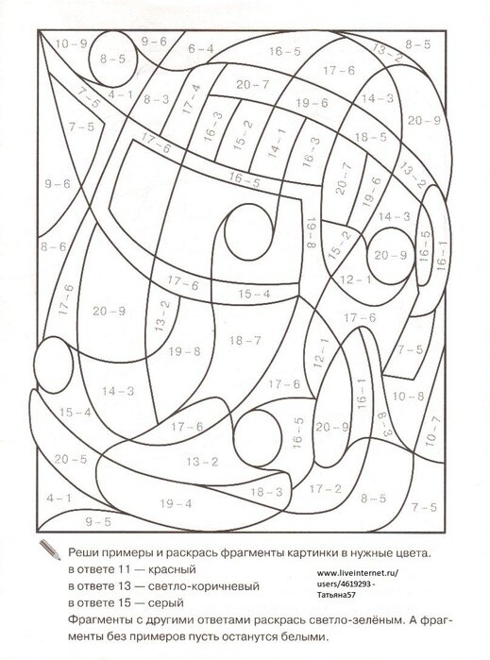](https://ok.ru/dk?cmd=PopLayerPhoto&st.layer.cmd=PopLayerPhotoOuter&st.layer.type=GROUP&st.layer.revNav=off&st.layer.limitedUi=false&st.layer.closeLayers=off&st.layer.sphotoIds=897039102766;897039102510;897039102254;897039101998;897039101742;897039101486;897039101230;897039100974;897039100718;897039100462&st.layer.showNav=on&st.layer.photoAlbumId=57769909354542&st.layer.epm=off&st.layer.photoId=897039101486&st.layer.wasRedirect,=off&st.layer.opl=off&st.layer.navStartPhotoId=897039101486&st.layer.navStartAlbumId,=57769909354542&st.layer.sbd=off&st.cmd=altGroupMain&st.groupId=57769908502574&st.referenceName=mentalnarif&st._aid=GroupTopicLayer_openPhotoLayer)